sdasdasd

**Skills and Knowledges**



**Operating System**

Microsoft Windows 10

Linux

**Programming Languages**

HTML

CSS

JAVASCRIPT

AJAX

Tailwind

**Back end**

PHP

Mysql

Express js

Npm

API

**Version Control**

Git

github

**PERSONAL DATA**

Date of Birth : August 17, 1995

Age : 27

Sex : Male

Height : 5’6

Weight : 64kg

Civil Status : Single

Nationality : Filipino

Religion : Roman Catholic

**EDUCATION**



## TERTIARY CAT COLLEGE Inc.

*2018-2021* Bachelor of Science in Information Technology

Balintawak, Barangay 16, Legazpi City

**TECHNICAL VOCATIONAL CAT COLLEGE Inc.**

*SEPT-NOV 2017* Electronics Product Assembly and Servicing NC II

## 

## SECONDARY Gogon High School

*2008-2012* Gogon Legazpi City

**JEFFERSON ECHALAS INDAYA**

**Affirmation of Statement**

I hereby affirm that the information contained in this resume is true to the best of my knowledge and conscience.

**Contact**

* +639 514 281 455

[jeffindaya@gmail.com](mailto:jeffindaya@gmail.com)



#494, Brgy.38, Lakandula Street Gogon Legazpi City

**References**

* Jazmar Ace Tan

Video Editor

* Kim Carla Morada

Teacher

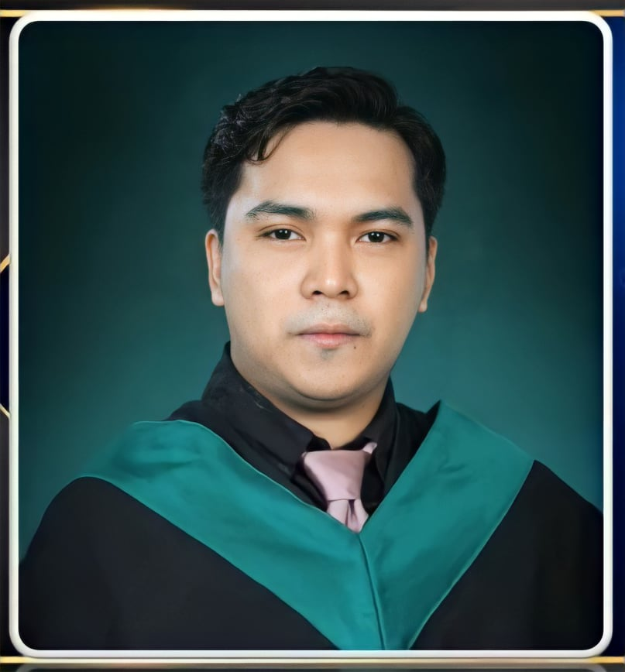

**Jefferson Echalas Indaya**

Applicant